Building for Actual Demand
A road map for every publicly subsidized housing decision in the Upper San Miguel — what the record says the Region needs, what each bed really costs, the rules that maximize workers housed per public dollar, and the mistakes to never repeat.
Livable Telluride · August 2026 · Draft for discussion · Restructures and supersedes the analytical sections of "Housing in the Upper San Miguel"; all evidence and endnote sourcing carries over.
1. First, the decision: what is subsidized housing for?
There are only two honest reasons for a government to subsidize housing. Reason one: house the workforce the Region already has — the people already holding its jobs, currently overcrowded, precariously housed, or commuting over Dallas Divide — while deliberately avoiding subsidies that recruit new demand. Reason two: grow — use housing to attract new workers for an expanding economy. Both are legitimate choices. They have opposite economics, opposite infrastructure consequences, and opposite end states — and a program that never chooses between them will drift into the second while claiming the first.
The Region has been drifting. The County’s own 2025 Housing Needs Assessment says so with unusual clarity: of the 1,114 units it identifies as "need," only about 16% — 182 units — house people who already live here. The other 84% accommodates relocating commuters, unfilled jobs, and jobs that do not exist yet.¹
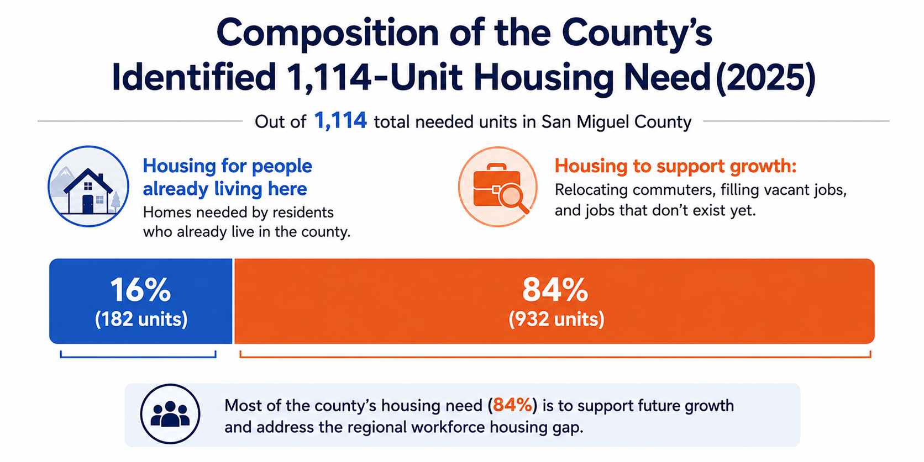
Exhibit 1. The composition of the County’s identified need. Choosing the need-catching lens shrinks the honest target from more than a thousand units to a finite program in the low hundreds of beds.
This road map adopts reason one — house the current workforce, do not subsidize growth — and everything that follows is the disciplined consequence of that single choice. A jurisdiction that wants reason two can choose it, but it should do so by vote, with the infrastructure bill attached, not by accident inside a housing program.
2. The demand that actually exists
Nobody measures demand systematically here — the towns keep no real vacancy records — but the Region has run three natural experiments that trace the demand curve precisely:²
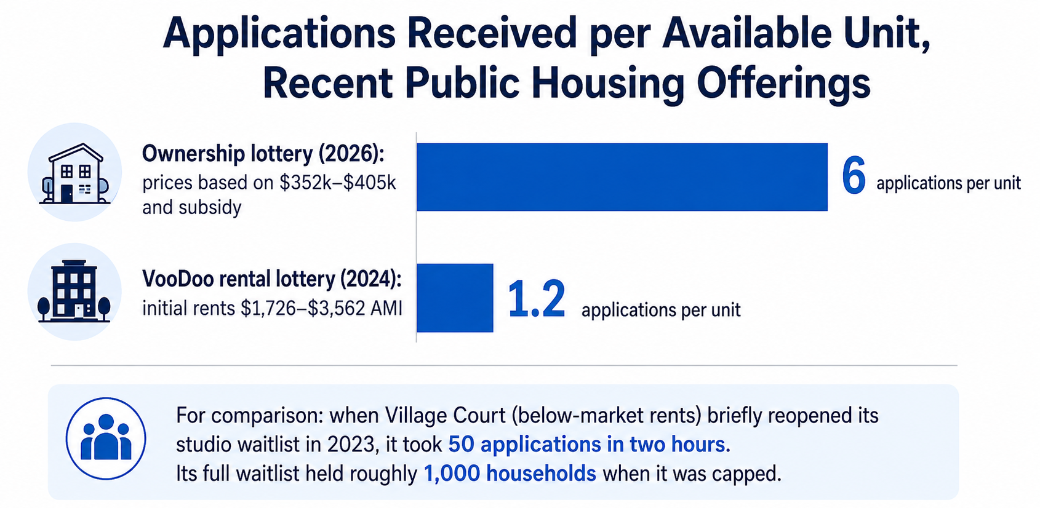
Exhibit 2. Applications per available unit. Below-market rents produce a ~1,000-household waitlist; subsidized ownership draws 6 applicants per unit; rental product priced near 140% AMI drew 1.2 applicants per unit and still had vacancies that December.
The pattern is unambiguous: demand is crushing below roughly 100% of Area Median Income, thins fast above 120%, and is nearly saturated by 140%. The reason is arithmetic, not preference — the Region’s actual wages cannot reach its actual rents:³
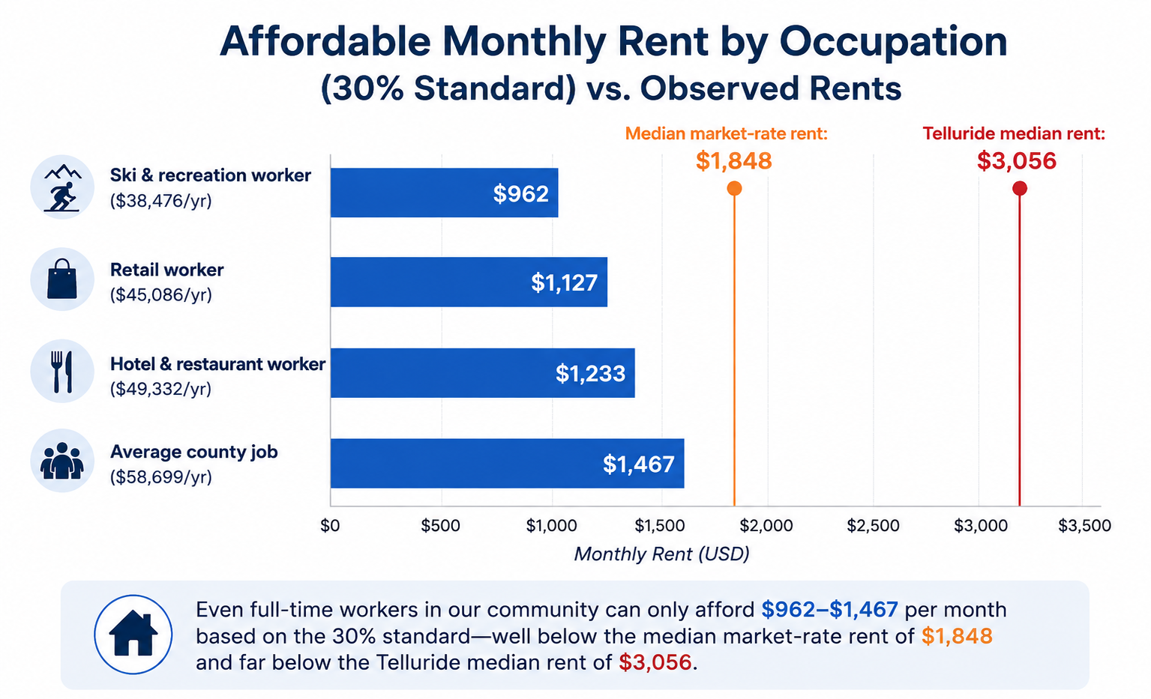
Exhibit 3. What full-time work here can afford. Even the average county job supports $1,467 per month against a $1,848 median market rent — and $3,056 in Telluride.
When the Town repriced its own portfolio to income-based rents in January 2025, it accidentally proved the same curve from the other side: 82 rents rose, vacancy in the portfolio hit roughly one unit in four, and the housing director confirmed on the record the empty units were "not because of a lack of demand."⁴
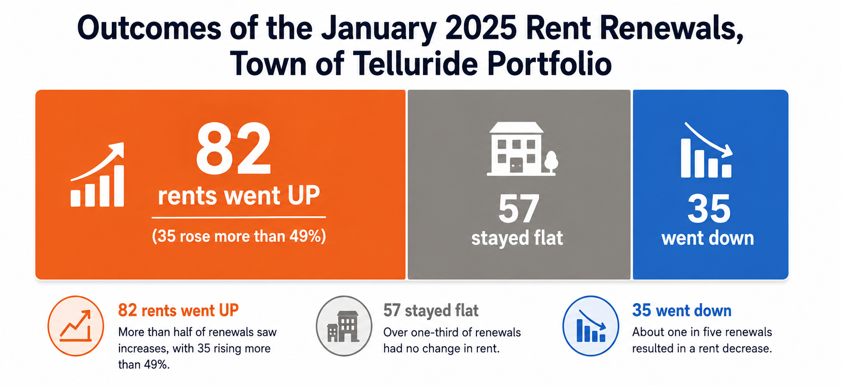
Exhibit 4. The January 2025 natural experiment. The Region ran a price-elasticity test on its own tenants; the vacancies that followed were a pricing phenomenon.
What this means for the target. Under the need-catching lens, the program is finite: the ~182 units of documented existing-resident need, plus whichever share of current in-commuters the Region deliberately chooses to bring home, minus what repricing existing stock recovers. That is a program measured in the low hundreds of beds, with a published end state — not a rolling thousand-unit ambition.⁵
3. What a bed costs, what a bed returns
Every proposed bed should face one threshold question — does it change who fills an existing job, or does it enable a new job? A bed that moves a Montrose commuter or an overcrowded local into stable housing adds almost no new demand to the Region: the job already exists, the worker’s services are already consumed, and workforce households sit at the very bottom of the measured home-service employment curve. A bed that lets a new enterprise staff up is growth accommodation wearing housing’s clothes, and belongs in a different conversation with the infrastructure bill attached.⁶
The return side. Housing an existing worker produces measurable value: roughly $18,000–19,000 a year in avoided vehicle costs for a Montrose commuter, a comparable amount in recovered time, employer turnover savings, peak-hour trips taken off the failing Society Turn intersections, and a filled seat in the school. Stated conservatively, each repatriated or stabilized worker returns on the order of $25,000–40,000 per year to the household, employers, and the public together.⁷ That number is the yardstick every instrument must beat.
The cost side. The Region has now price-discovered nearly every way to create a below-market bed, and the results span two orders of magnitude:⁸
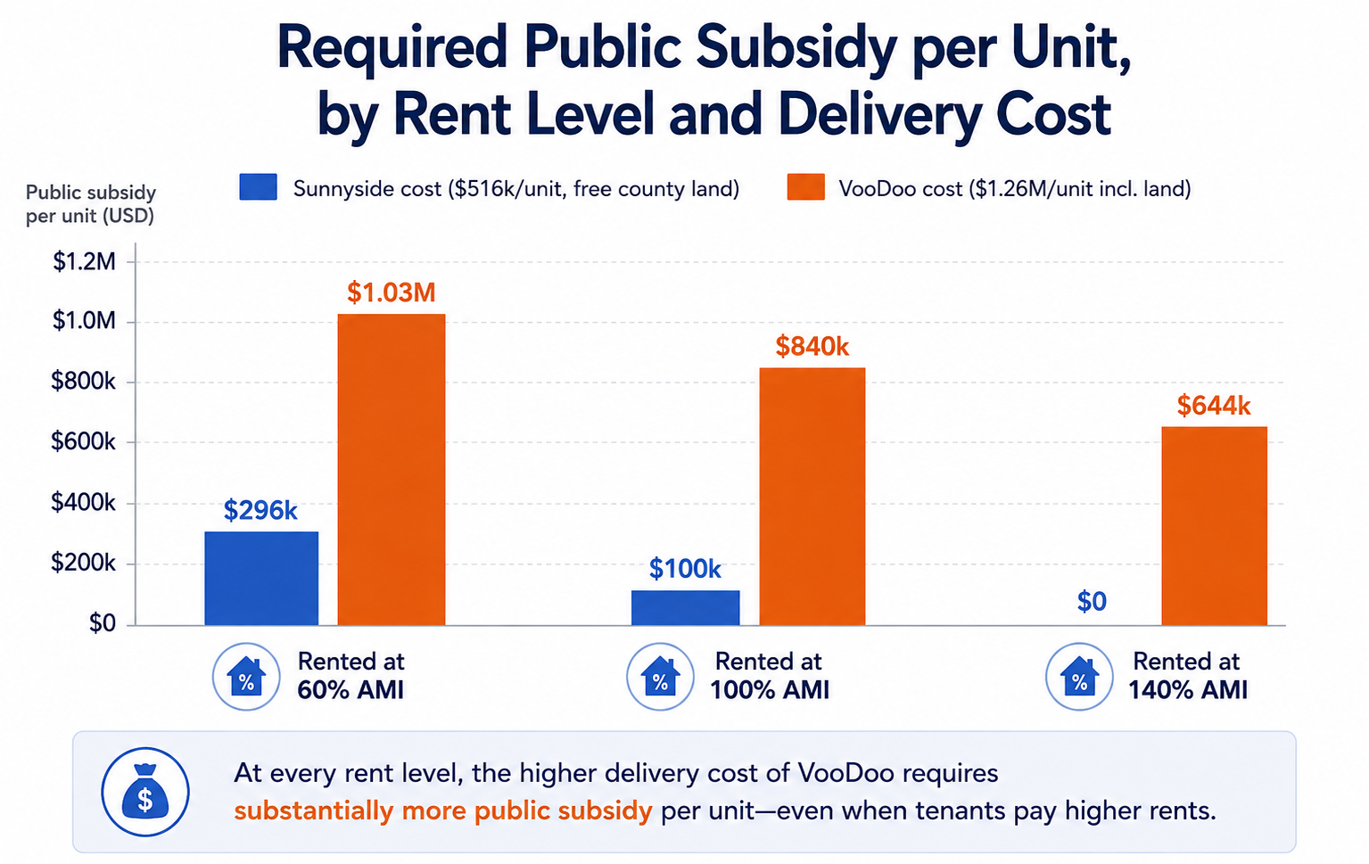
Exhibit 5. Public subsidy per new unit, by rent level and delivery cost. Delivery cost — land and construction choices — sets the subsidy, not operating decisions. The same 100%-AMI tenant costs the public $100k in a Sunnyside-class building and $840k at VooDoo cost.
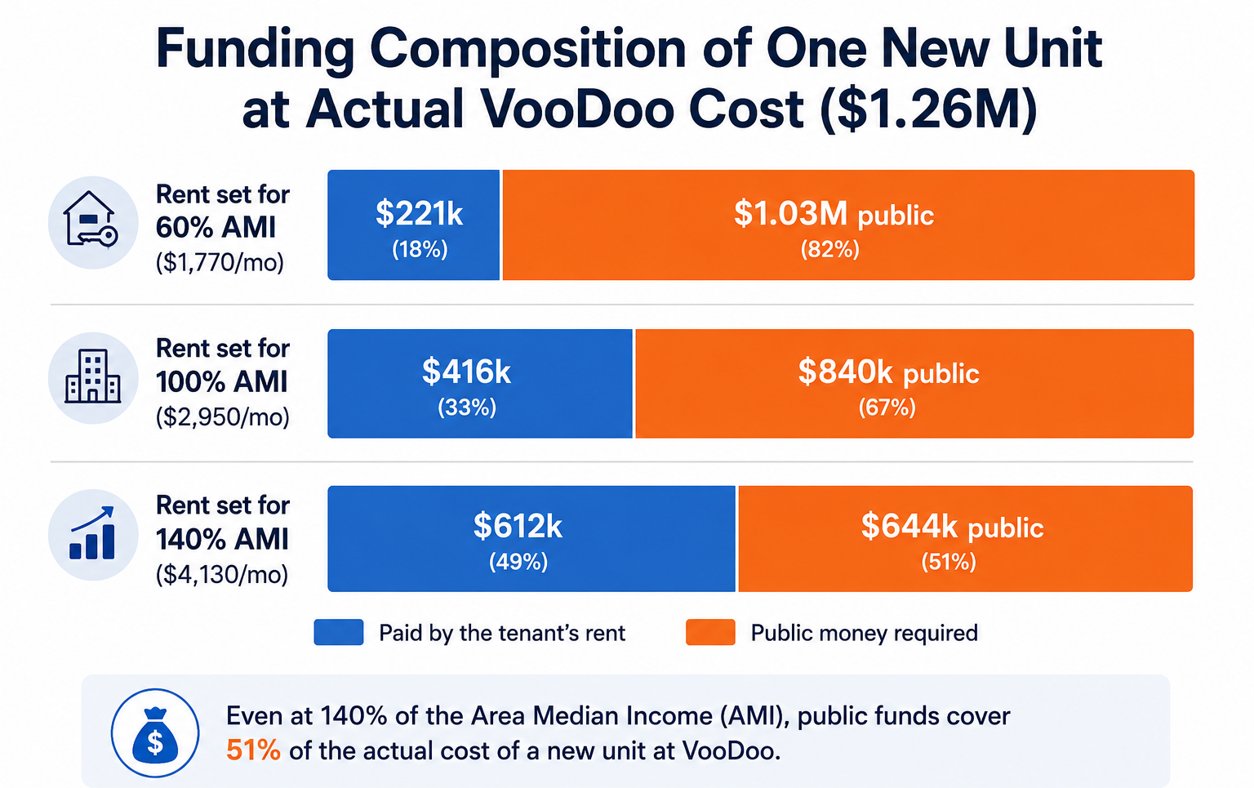
Exhibit 6. Where the money comes from at actual VooDoo cost. Even tenants paying 140%-AMI rents cover barely half the cost of their own unit — which is why pricing followed cost up the income scale, straight out of the demand curve of Exhibit 2.
4. The efficiency frontier
Rank every instrument by net public cost per worker-housed-year against the $25,000–40,000 return, and the shopping list orders itself:⁹

Instrument | Public cost per bed | Annualized | Induced growth | Return vs cost
1. Reprice the ~49 vacant town units | ~$0 capital | ~$2–4k/yr | none — units exist | ~10 : 1
2. Buy deed restrictions (InDEED-style) | ~$30–35k one-time | ~$2k/yr | none — no construction | ~10 : 1
3. Master-lease existing free-market units | ongoing | ~$5–15k/yr | none, reversible | 2–5 : 1
4. Meadowlark-class ownership, public land | ~$61k/bedroom | ~$4k/yr | small | ~5 : 1
5. VCA-4-class modest rental, free land | ~$45k cash/bedroom | ~$5k/yr | small | ~4 : 1
— the cliff —
VooDoo-class bespoke construction | ~$700k+/bed | ~$45k+/yr | full | below 1 : 1
Lot L-class (garage-burdened) | ~$1.5M+/bed | ~$100k/yr | full | far below 1 : 1

Two facts organize everything above. First, the top three rows house the identical worker at 5–20% of construction cost, with zero draw on sewer, roads, or the construction labor market — under the need-catching lens they are not merely cheaper, they are the only instruments fully consistent with the lens. Second, below the cliff line, the annualized public cost of a bed exceeds the entire yearly benefit of housing the worker in it. The Region has been operating below its own break-even line, which is why the housing budget grows while the problem does not shrink.
5. The ceiling that makes discipline mandatory
This is not merely a question of thrift. The Region’s shared systems are at or past their limits — the sewage plant is over its organic rating, past the State’s 80% planning trigger, and operating on an expired, administratively continued permit — and its replacement offers roughly 1.0–1.1 million gallons per day of headroom to serve every project, jurisdiction, and visitor bed for a generation.¹⁰
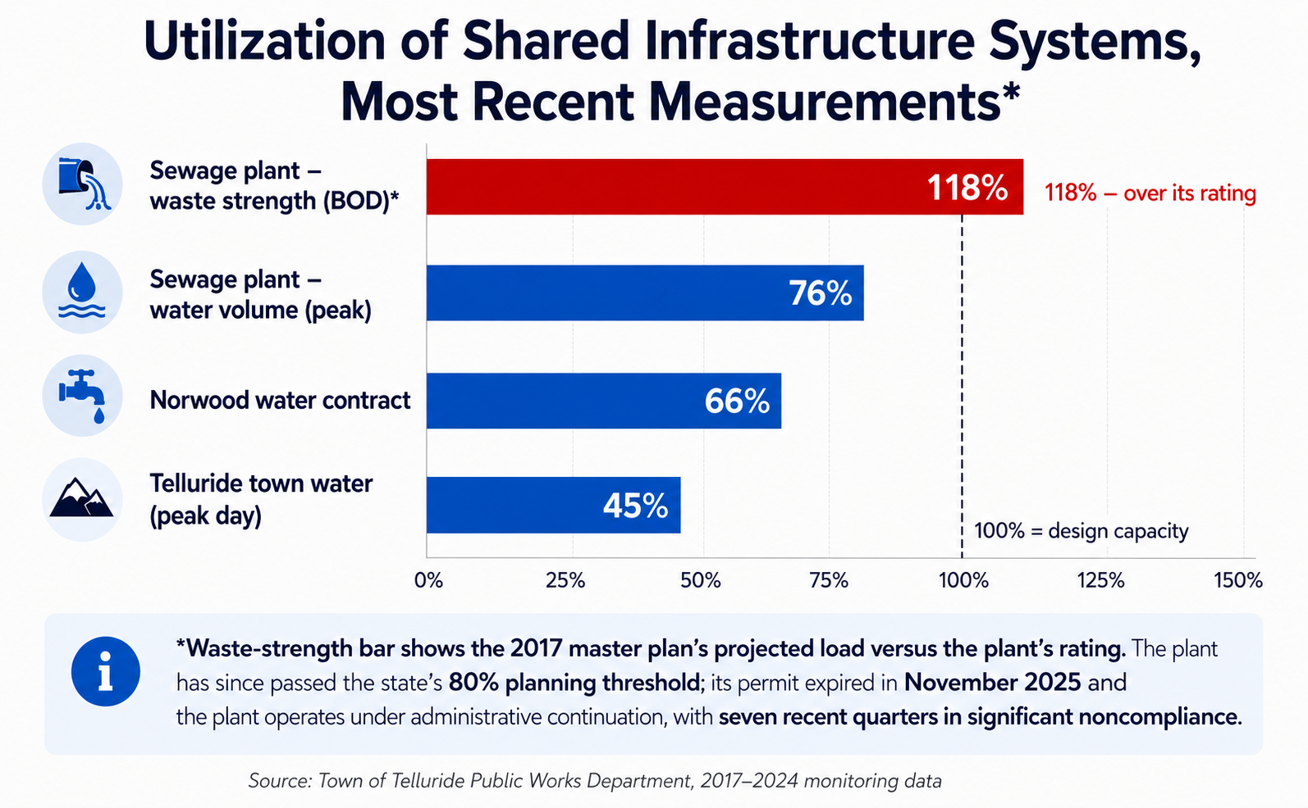
Exhibit 7. Utilization of the shared systems. Every construction bed draws down a fixed, nearly exhausted envelope; every frontier bed (rows 1–3 above) draws nothing.
The committed pipeline — two five-star hotels, Society Turn, the Ilium rentals — already claims a large share of that headroom before any new proposal is considered.¹¹ A housing program that builds when it could restrict, lease, or reprice is spending two scarce currencies at once: public money and the Region’s last infrastructure margin.
6. The Rules
For the planning department: the ten rules below convert this record into decisions. They are written to be applied in order, in public, to every proposal that asks for public money, public land, a density bonus, or a fee waiver.
Rule 1 — Decide the lens before the project.
Every proposal states, in its first paragraph, whether it houses the current workforce or accommodates growth. Growth accommodation is a legitimate elected choice — made by vote, with the infrastructure and service bill attached — never a default inside a housing program.
Rule 2 — Count first, build last.
The program target is the documented existing deficit plus the chosen commuter-repatriation share, published annually with an end state. No project is approved against "projected need." When the target is met, the program sunsets to maintenance mode.
Rule 3 — House existing jobs, not future ones.
Eligibility requires current employment in the R-1 district with tenure (for example, one year). Priority order: overcrowded and displaced residents first, current in-commuters second, nobody else. A bed must change who fills an existing job.
Rule 4 — Exhaust the frontier in order. Never skip a rung.
Reprice what sits empty → buy restrictions while sellers exist → master-lease the flexible margin → build modest on public land only for the measured residual. A proposal to build is simultaneously a claim that every cheaper rung is exhausted; make the applicant prove it.
Rule 5 — Never pay more per bed-year than the bed returns.
The benefit of housing one worker is $25,000–40,000 a year. Annualized all-in public cost per bed must stay below it — in practice, an absolute capital ceiling around $300,000–450,000 per bed, and realistically the free-land, modest-specification class. Anything above the line makes the community poorer with every bed it fills.
Rule 6 — Price to the demand curve.
New below-market product is priced at or below the ~100%-AMI equivalent, where the queue is. Product above ~120% AMI has documented near-zero excess demand (Exhibit 2); building it converts public money into vacancy.
Rule 7 — Meadowlark windows, never Pinion Park traps.
Ownership restrictions use employment and appreciation caps with no income limits, or wide ones — the design that sold 28 of 29 units in two months. Income caps set near the qualifying price manufacture the "unicorn buyer" and strand the homes.¹²
Rule 8 — Prefer beds that don’t flush.
Instruments that add zero infrastructure load (repricing, restrictions, leases) outrank construction wherever both can house the same worker. Construction proposals state their gallons-per-day and peak-trip draw against the published regional headroom.
Rule 9 — No mitigation laundering.
Beds created with public money are never credited against commercial mitigation requirements or used to unlock new commercial square footage. That channel converts workforce housing back into growth fuel and voids Rule 1.
Rule 10 — Publish occupancy monthly; sunset what stops filling.
Vacancy, waitlist, and turnover by property, size, and tier, published monthly. Any tier vacant over 90 days triggers automatic repricing review. Instruments are chosen to be reversible where possible, because a need-catching program is supposed to end.
The avoid list — reject on sight
- Bespoke in-town construction above ~$500,000 per unit — below break-even before the doors open.
- Any project justified by projected job growth — that is Reason Two; send it to the voters with the infrastructure bill.
- Income caps within reach of the qualifying price — the Pinion Park unicorn-buyer design.
- Rental product priced above ~120% AMI — demonstrated 1.2:1 demand and December vacancies.
- Structured parking inside a housing pro-forma — the Lot L pattern; parking is a transportation project.
- Perpetual subsidies for seasonal or cyclical needs — use master leases, which can end.
- Demand evidence consisting of a consultant projection instead of a waitlist — the Region has real queues; use them.
7. The scorecard
One page, ten questions, applied in public session to every proposal requesting public money, land, density, or waivers. Eight yes answers to proceed; any avoid-list feature stops the proposal regardless of score.

# | Question | Answer
1 | Does the proposal state its lens — and is it need-catching? | Yes / No
2 | Does it count against the published deficit, not a projection? | Yes / No
3 | Will every bed house a current R-1 worker (tenure eligibility)? | Yes / No
4 | Is every cheaper frontier rung demonstrably exhausted? | Yes / No
5 | Is annualized public cost per bed under the $25–40k/yr return? | Yes / No
6 | Are rents/prices at or below the ~100%-AMI equivalent? | Yes / No
7 | Are eligibility windows wide (employment-based, not income-trapped)? | Yes / No
8 | Is infrastructure draw zero — or stated and de-minimis against headroom? | Yes / No
9 | Is it firewalled from commercial mitigation credit? | Yes / No
10 | Does it carry monthly occupancy reporting and a sunset trigger? | Yes / No

8. The Region’s own projects, scored
The rules are not hypothetical; the Region has already run the experiments. Scored retrospectively:¹³

Project | Score | What the scorecard catches
Meadowlark (2024) | 9 of 10 | Passes nearly everything: public land, ~$61k/bedroom, wide eligibility windows, sold out in two months. The one miss: no published sunset/occupancy regime. The Region’s own council concluded 41 units would have beaten 29 — density spreads the subsidy.
VCA Phase 4 (2024) | 9 of 10 | Modest spec, free land, ~$45k cash/bedroom, priced where the waitlist is; the waitlist visibly moved. The template for the rental residual.
Pinion Park (2021–) | 5 of 10 | Right lens, right price point — wrong window. Income caps near the qualifying price plus one-time sweetheart financing: five homes unsold up to twenty months, one qualification application. Fails Rule 7 exactly as written.
VooDoo (2023–24) | 3 of 10 | Fails Rule 5 ($955k/unit all-in), Rule 6 (rents near 140% AMI → 1.2:1 demand, December vacancies, eligibility loosened to fill), and the natural-experiment aftermath fails Rule 10. The most expensive lesson in the ledger — and the reason this road map exists.
Shandoka Lot L (proposed) | 1 of 10 | A parking structure wearing a housing pro-forma: ~$3.3M per unit. The avoid list exists for this.

9. What the whole program costs — and when it ends
Size the need-catching program honestly and it is startlingly affordable. Roughly: the ~49 vacant town units recovered by repricing (≈70 beds, no capital); 40–60 purchased restrictions as sellers appear (≈$3–4 million); a master-lease margin flexed to the season; and a built residual of 150–250 bedrooms at Meadowlark/VCA-class costs (≈$7–15 million) — a complete program on the order of $15–25 million over a decade, with a defined end state.¹⁴
For scale: that is less than the all-in public cost of the single VooDoo project ($26 million for 27 units), and a rounding error against the $120–150 million gondola replacement or the nine-figure wastewater program. The Region does not have a housing-money problem. It has a housing-instrument problem — and the frontier instruments have been sitting unused at the top of the list while the most expensive one absorbed the budget.
When the published deficit closes, the program ends: leases sunset, construction stops, the restriction fund becomes opportunistic, and the occupancy dashboard becomes the early-warning system for the next cycle. That is what a housing policy with an end state looks like — and it is the difference, fifty years on, between Whistler and Aspen.¹⁵
10. What would change these conclusions
- A demand survey (willingness-to-apply at real rent × size × location) materially larger than the documented queues — it would resize the target, not reorder the frontier.
- A restriction-purchase market that proves thinner than Vail’s — it would shift weight toward master leasing and the built residual.
- The Sewer Authority publishing a final design population — it would replace the headroom estimates in Section 5.
- A jurisdiction voting explicitly for growth — Reason Two has its own honest math; this road map governs only the need-catching program.
Endnotes
1. San Miguel County Housing Needs Assessment (2025): 1,114-unit identified need; ~16% (182 units) attributable to existing resident households (overcrowded, temporarily housed, displaced); the remainder to in-commuter relocation, unfilled positions, and projected job growth.
2. Demand evidence: Village Court Apartments waitlist ~1,000 households when capped (2020); 2023 studio-list reopening rationed to 50 applications in two hours; SMRHA 2026 ownership lottery 18 qualified households for 3 units (6:1); VooDoo 2024 rental lottery 33 applicants for 27 units (1.2:1), five units unleased that December, eligibility subsequently loosened. Full sourcing in the companion report, endnotes 14–19.
3. Wages: BLS QCEW San Miguel County (2024–25) by sector; affordability at the 30% standard; market rents from the regional listing audit (2026) and HUD FMR. Companion report, Section 2.
4. January 2025 income-based renewals, Town of Telluride portfolio: 82 rents increased (35 by more than 49%), 57 flat, 35 decreased; April 2026 vacancy 49 of 201 town-managed units; Housing Director quoted that vacancies were "not because of a lack of demand." Town records and Telluride Daily Planet coverage.
5. [E] Program sizing: 182 HNA existing-resident units + a chosen repatriation tranche (100–200 beds) − repricing recovery (~70 beds) → a program of roughly 250–400 beds. The Livable Telluride survey is designed to refine the repatriation tranche with willingness-to-apply data.
6. The existing-job test and the home-service employment curve: measured 0.01 FTE (local studio) to ~1 FTE (15,000 sq ft second home); workforce households occupy the curve’s bottom. See "Who Works for a House?" (Livable Telluride, August 2026), Exhibits and endnotes 1–3, 9.
7. [E] Benefit stack per repatriated Montrose commuter: ~65 miles × 2 × ~220 days × $0.65–0.70/mile ≈ $18–20k vehicle cost; ~2.5 hours/day travel time at modest valuation ≈ $14k; employer turnover avoidance (industry convention 30–50% of salary per replacement, amortized); public increments (peak-hour trips off the Society Turn/Last Dollar pair, road wear, SMART subsidy offset, school enrollment). Stated as $25–40k/worker/year; used only to rank instruments, whose ratios differ by an order of magnitude.
8. Delivery-cost ladder, all-in public cost: Vail InDEED restriction purchases ~$62–68k/unit (~162 units executed); Meadowlark ~$137k/unit net (~$61k/bedroom; 29 units, 65 bedrooms, $4.3M buy-down within a ~$6M town contribution less ≥$1.6M recovered); VCA Phase 4 ~$4M town cash on 35 units/88 bedrooms ($22.6M total, $15M lease-purchase serviced by rents, $3M+ grants); Sunnyside-class $516,103/unit development cost on free county land; VooDoo $1,255,635/unit development cost, ~$955k/unit all-in public; Shandoka Lot L proposal ~$3.3M/unit including a 900-space garage. Companion report, Sections 3–5 and endnotes 20–28, 56–59.
9. [E] Frontier arithmetic: per-bed figures convert per-unit costs at observed bedrooms per unit; annualization at 30 years; return-to-cost ratios use the note 7 benefit range against annualized all-in cost. Repricing "cost" is forgone rent premium on units currently producing zero rent; master-lease costs bracketed from peer programs (Lease to Locals class).
10. Regional WWTP: past the State 80% organic-loading planning trigger; permit CO0041840 expired November 30, 2025, administratively continued; 7 of 13 recent quarters in Significant Noncompliance; on-site expansion canceled after 30% design exceeded $133M for ~0.2 MGD; replacement 2.67 MGD Ilium plant (June 2025 MOU), Sewer Authority due July 1, 2028. Headroom ≈ 2.67 − ~1.6 current peak ≈ 1.0–1.1 MGD ≈ 10,000–15,000 people at 70–100 gal/person/day [E]. Companion report, Section 6 and endnotes 35–37, 60–62.
11. Committed pipeline: Four Seasons (26 residences + 43 hotel residences, no on-site employee housing identified), Six Senses 109R (~101 lodging units + ~26,000 sq ft commercial, 20 on-site employee units), Society Turn (≤125 rooms, hospital, ~188,000 sq ft commercial, 91–121 employee units), Ilium 70–100 rentals. Companion report, Section 7 and endnotes 63–66, 73–75.
12. Meadowlark: no income limits, 1,560 hrs/yr R-1 employment, 4% appreciation cap, MVHA first offer — 28 of 29 sold within two months. Pinion Park: 120% AMI caps (80% on some units) at ~$370k prices; original affordability carried by a one-time 2.5% no-down mortgage unavailable at resale; five of 24 homes listed unsold 5–20 months; one qualification application received; Commissioner Waring’s "unicorn buyer." Companion report, Section 4.2 and endnotes 56–59.
13. [E] Retrospective scores apply the ten rules as written to the documented record of each project; reasonable people may move any single project one point either way without changing the ordering.
14. [E] Program cost: restrictions 40–60 × $65–70k ≈ $2.8–4.2M; built residual 150–250 bedrooms × $45–61k ≈ $7–15M; master-lease flow budgeted annually; repricing capital-free. Total $15–25M excluding land already publicly held. Comparators: VooDoo ~$26M all-in for 27 units; gondola replacement estimate $120–150M; regional wastewater program nine figures.
15. Whistler capped bed-units, made the housing target finite, houses ~84% of its workforce locally; Aspen mitigated at higher rates for fifty years without an end state and imports ~7,500 workers daily. Companion report, Section 7 and endnotes 39–44.
— Draft for discussion. Livable Telluride welcomes corrections; the road map improves when readers find its errors. Full evidence base: "Housing in the Upper San Miguel — Public Report with Endnotes" and the graded evidence files at livabletelluride.org.

